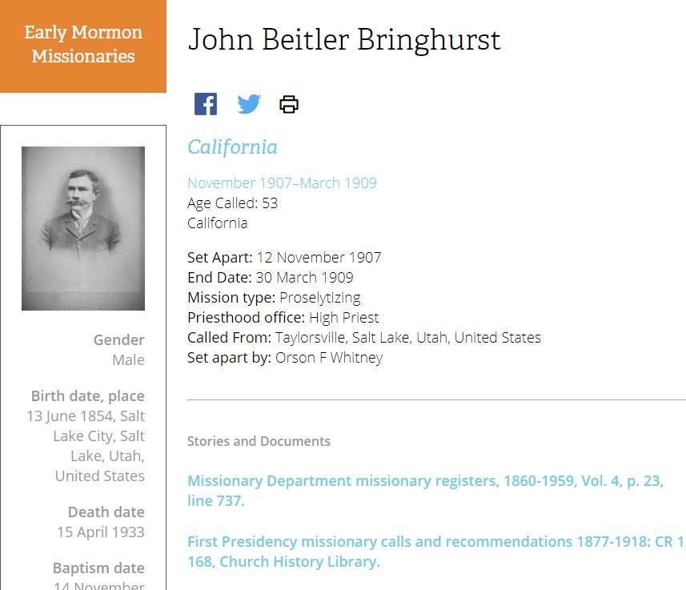Family History Nuggets
Discover Missionaries in Your Family Tree
Ever wonder about the brave men and women who were the early church missionaries?
Google familysearch.org/discovery then click on “Missionaries”. FamilySearch finds all the early church missionaries (from 1830-1930) in your tree. There can pictures, stories, letters, journal entries. It can tell you vital statistics, who baptized them, when and where they served, type of mission and who set them apart. I have found letters by Joseph Smith to my ancestor, I have seen letters from my an- cestors telling a long story of the hardships they were having and maybe why they couldn’t serve a mission at a particular time. There have been journal entries that shed light on their life and the people they loved. Check out these amazing people who may have helped shape your life.

For help with your family history or questions call Jane Doe (Ward History consultant) at 801-867-9365. If you would like to receive these FH Nuggets through email, send a request to janedoe@gmail.com

Family History Nuggets
Ever wonder about the brave men and women who were the early church missionaries?
Google familysearch.org/discovery then click on “Missionaries”. FamilySearch finds all the early church missionaries (from 1830-1930) in your tree. There can pictures, stories, letters, journal entries. It can tell you vital statistics, who baptized them, when and where they served, type of mission and who set them apart. I have found letters by Joseph Smith to my ancestor, I have seen letters from my an- cestors telling a long story of the hardships they were having and maybe why they couldn’t serve a mission at a particular time. There have been journal entries that shed light on their life and the people they loved. Check out these amazing people who may have helped shape your life.

For help with your family history or questions call Jane Doe (Ward History consultant) at 801-867-9365. If you would like to receive these FH Nuggets through email, send a request to janedoe@gmail.com

